** **PROJECT TITLE**

**Contents**

**List of Table**

# **List of Figures**

# **List of Abbreviations**

# Chapter 1

## Introduction

### 1.1 Key features

# Chapter 2

## Architecture

### 2.1 Testbench Architecture

# 

# Chapter 3

## Implementation

# Chapter 4

## Directory Structure

### 4.1.Package Content

# 

# 

# Chapter 5

**Coverage**

### 5.1 Template of Coverage Plan

# 

# Chapter 6

## Test Cases

### 6.1 Test Flow

In the test, there is virtual sequence and in virtual sequence, sequences are there, sequence_item get startedin sequences, sequences will start in virtual sequence and virtual sequence will start in Test.

[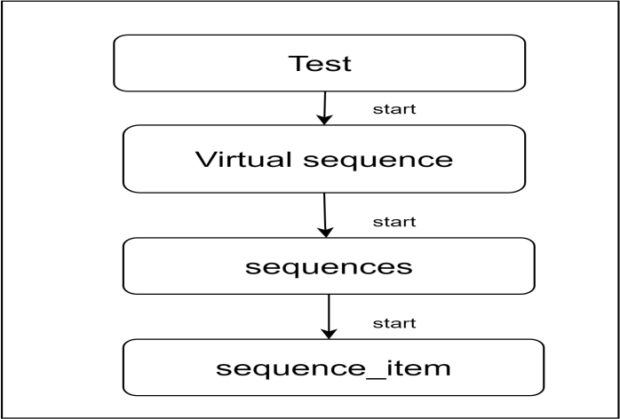](https://app.diagrams.net/?page-id=dnmm31B8M5x43_O-oxbx&scale=auto#G14efqYN0hjCcjijkMFQeD24eAYpKeaZi7)

**Fig 8.1** Test flow

### 6.2 Test Cases

# Chapter 7

## References

Add the reference document link related to these project